Battle of Two Armies Documentation

**Language:**   
C#

**Program Type:**   
WinForms Application

**Description:**  
My thought when creating this application is that you have three different unit types on the battlefield, each with their own unit value. This unit value for EACH unit is multiplied by a random number between 0 and 100 giving a “Unit Strength”. The “Unit Strength” of each army is compared against one another and a winner is decided.

**Program Evolution:**   
I initially created this program as a console application, but when I showed the lady of my life (Nursing Student) the finished product she stated it needed more pictures. So I ripped out the core of the console application and threw it into a GUI that was much more user friendly.

*Battle of Two Armies 1.0*

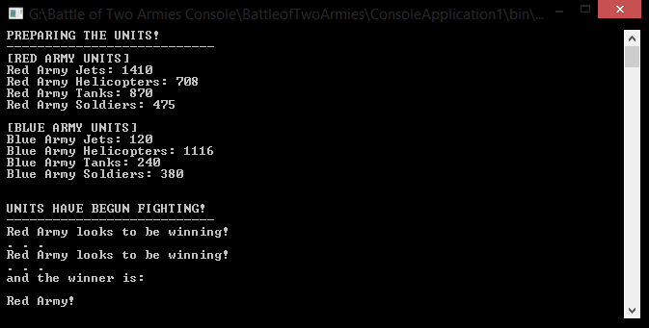

*Battle of Two Armies 2.0*